**Assignment 5.5**

**Dataset:**

Download the Titanic data set from the below link

Titanic_Dataset

**DATA SET DESCRIPTION:**

Column 1: PassengerId

Column 2: Survived (survived=0 & died=1)

Column 3: Pclass

Column 4: Name

Column 5: Sex

Column 6: Age

Column 7: SibSp

Column 8: Parch

Column 9: Ticket

Column 10: Fare

Column 11: Cabin

Column 12: Embarked

**Program:**

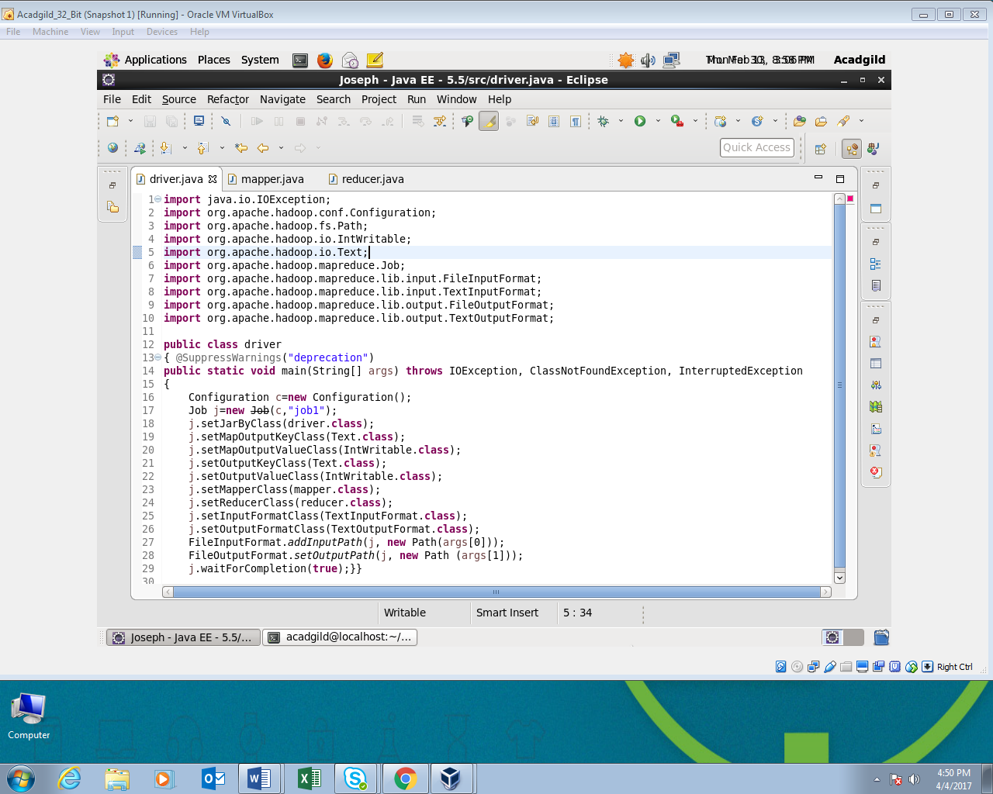

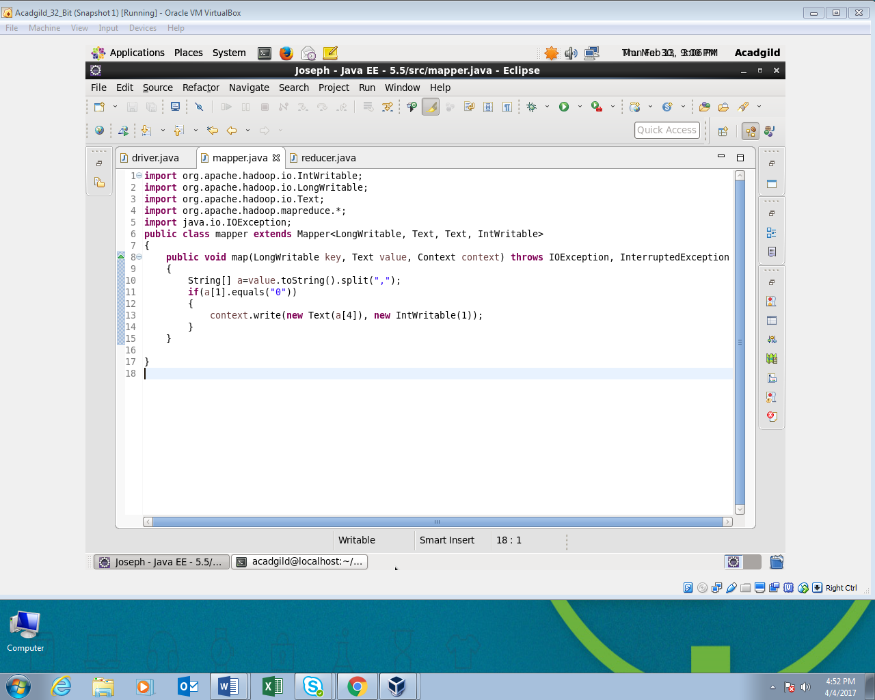

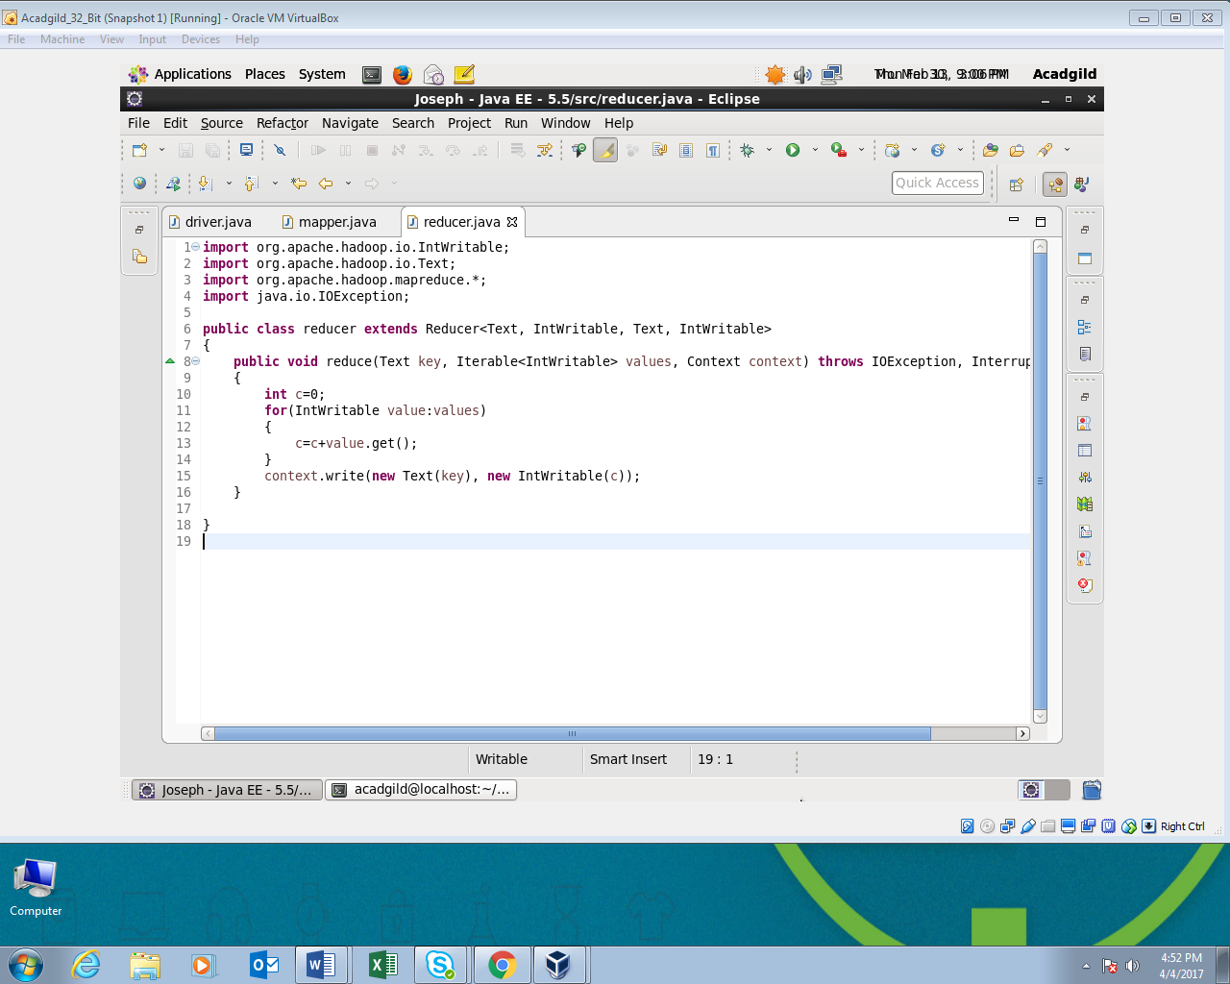

**Output:**

